NIHR Three Research Schools’ Mental Health Programme

Improving mental health and wellbeing in underserved populations through collaborative research

Projects to improve patient and public involvement and engagement (PPIE)

RESEARCH BRIEF

The NIHR Schools for Primary Care Research (SPCR), Public Health Research (SPHR) and Social Care Research (SSCR) (“three schools”) have joined together in a unique collaboration between leading academic centres in England to collaborate on three programmes of work funded through the National Institute for Health Research (NIHR): one on mental health led by SPCR, the second on dementia led by SSCR and the third on prevention led by SPHR.

Background:

At least one in four people experience mental health problems, many of whom never access care and treatment. There are also large numbers of people with learning disability (prevalence c.2%) and autism (prevalence c.1%). See appendix one. Mental health problems, learning disabilities and autism generate challenges for individuals with these conditions, their families and the wider society, with often quite high utilisation of health, social care and other services. Those challenges are seen across the life course.

The impacts of mental health problems on individuals and the wider societal and economic consequences are multiple and vast and include above-average rates of concurrent physical illnesses, shortened life expectancy, social exclusion, socioeconomic disadvantage, and the need for health and welfare support. Despite the high prevalence, many people do not receive the support they need and there are significant inequalities in access. These underserved groups include, but are not limited to, people with learning disabilities, older people, parts of the autistic and neurodiverse community, people from Black and other ethnic minority backgrounds. There are also other geographical, demographic and socioeconomic inequalities which this call addresses.

By working collaboratively across primary care, public health and social care, we aim to address problems in a multi-professional, multi-disciplinary way and at the individual, family, group and population levels using a variety of methodological approaches. Research will be underpinned by strong and diverse public, carer, service user and patient, and, as appropriate, practitioner involvement and engagement. Our research will prioritise those groups with high needs for treatment and support, and that have been underserved by research to date.

The requirement:

Funding awarded to the Three Schools in phase I (2021-24) has supported 53 projects (Three NIHR Research Schools' Mental Health Programme — NIHR School for Primary Care Research). Awards included a diverse range of partners, including practitioners, local authorities and those working in the third sector. Funding also achieved a wide geographical reach, actively working with populations and communities not traditionally engaged in research. We established a Fellowship scheme to develop new research capacity in key topic areas and localities in need of capacity development.

Research funding in phase 2 will build on early successes, supporting the implementation of evidence into practice and policy. Several areas were significantly represented in phase 1. These include suicide prevention in high-risk groups (including those working in the agricultural sector and young men), mental health in pregnancy, prison mental health, mental health in different religious groups and mental health in military veterans and we have been prioritising applications in these areas but we will also consider other topics.

Opportunity

The Three Schools have a strong track record in public and community involvement and engagement. This ensures our research is more accountable, relevant and timely and promotes the relevance of our work to practitioners, policymakers and research users. Public and community involvement and engagement will continue to underpin all our activities and we will ensure the public continue to be involved in all aspects of our mental health programme. This includes working in partnership with those with lived experience, families, carers and across settings including prisons, schools, care homes, domiciliary care, and Voluntary Community and Social Enterprise (VCSE) who deliver services.

To support increasing our understanding of working with these populations we would like to support a number of projects to improve public and community involvement and engagement and will specifically address working with the most underrepresented groups.

There is no single definition of an underserved group, and this will be context specific to your research area. Often, those underserved can be identified as those less likely to be included in research and have opportunities to share their views, experience and influence developing research. The NIHR INCLUDE study identified some examples of underserved groups in research, however this is not an exhaustive list.
We recognise that building trust and relationships with communities takes resource, time, and different approaches to involvement. Therefore, this call provides funding for individuals to trial and/or evaluate different approaches to involvement with these communities. It is our hope that through this funding researchers and research teams will be able to improve understanding of how best to work with these communities which can inform ongoing an/or future research.
Some ways the funding could be used include, but are not limited to:
- Exploring and/or building understanding of underserved community priorities and unmet needs.
- Exploring, developing and/or evaluating new and creative ways of working in partnership with underserved groups/communities.
- Understanding underserved groups/communities’ views about research, including facilitators and barriers to their involvement across the research cycle.
- Methods for developing research interest or understanding in groups and communities.
- Effective and inclusive engagement approaches using creative arts, new technologies or participatory approaches.
- Ways of engaging and involving groups who are underrepresented in research.
- Ways of implementing patient and public involvement and engagement at scale across communities.
- Approaches for identifying and developing community health and social care priorities as research proposals.
- Approaches to engaging with and inclusion of peer researchers.
Funding of research through this programme requires collaboration between at least two different NIHR Schools. It is important that applicants ensure that they are listing collaborators who are member of one of the Three NIHR Schools:
NIHR School for Primary Care Research
NIHR School for Public Health Research
NIHR School for Social Care Research*

*SSCR has new membership from 1.5.24. However, NIHR have not yet announced the new members. If you have any queries, please contact Jen Hill, Programme Manager, NIHR SSCR.

The Principal Investigator must be based in one of the members of one of the three NIHR Schools (see links above). Collaborators from outside the three Schools are allowed but there must be collaboration from at least two of the three NIHR Schools.

The host organisation must be based in areas identified by the NIHR ‘heat map’ (appendix 1) as being underserved, however collaborators outside of these areas are welcome. Participant recruitment to the study must take place from the underserved region although this can be in conjunction with sites located in other regions, where the burden or need is high. The choice of recruitment regions and sub-localities must be justified in relation to the size of the impacts. We encourage applicants to use a mapping tool, such as the Research Targeting Tool (to access this please contact inforequest@nihr.ac.uk), to demonstrate how the planned target population fit with prevalence and impacts. Special consideration should be given to the inclusion of people from socioeconomically disadvantaged groups and other underserved communities that are more affected by mental health problems. Research methods may involve primary research or evidence synthesis, including systematic reviews, intervention development and testing, modelling studies, or the analysis of existing datasets.

Selection criteria:

A good application should demonstrate the following:
- Early and sustained relationship building with relevant people, public groups, and communities.
- Clear reach into underserved communities.
- Reciprocity in research so that people and communities, as well as the researchers, clearly benefit from engagement.
- Fair, appropriate, and justifiable distribution of funding between research and community partner organisations.
- Use of creative ways to better serve those traditionally underserved.
- Built-in evaluation of the impact of the innovative approaches to involvement, engagement and/or co-production.
- Plans that clearly demonstrate how the applicants will ensure continued engagement between partners after the funding ends e.g. demonstrable co-production.
Applications will be reviewed using the following criteria:

- Relevance and importance to the priorities and needs of primary care, public health and social care.
- Clear alignment with the remit of the Three NIHR Research Schools’ Mental Health Programme.
- Awareness and understanding of previous relevant research or developments in this area.
- Feasibility of planned research.
- Originality of planned research.
- Appropriateness of the research design. Are the methods appropriate for the underserved communities the research is focussed on?
- Appropriateness of the work plan and project management arrangements.
- Strength of the research team.
- Strength of the dissemination and impact plan.
- Strength of the proposed plans for patient and public involvement throughout the duration of the research.
- Demonstrable co-production of research plan and activities.

Funding:

The maximum budget for each proposal is £50,000 for this call. This can fund:
- 100% of the directly incurred staff time on the project
- 100% of the directly allocated staff time on the project
- Overhead of 30% of the directly incurred staff cost
- Overhead of 30% of the directly allocated staff time cost
- 100% of the directly incurred non-pay items
- As this is NIHR funding, overheads cannot be applied to non HEI organisations, including; local authorities, NHS providers and other third party organisations. Non HEI organisations must be costed at 100%. Overheads should be removed from the ‘Institutions & Organisations’ worksheet of the costing template where appropriate.

Awards can be of any duration but STRICTLY must not extend beyond 31 March 2026.

Applications should be emailed to c.ashmore@keele.ac.uk by Friday 13 December 2024 no later than 3.30pm.

TIMETABLE

Tuesday 5 November 2024 | Competition launch
Friday 13 December 2024 at 3.30pm | Closing date for submission of applications
January 2025 | Panel meeting to discuss applications
January/February 2025 | Competition outcomes to be announced
March 2025 | Awards may start from this date

GUIDANCE NOTES

PART 1 – APPLICATION SUMMARY

Plain English Summary
Guidance on writing a plain English summary is available at https://www.nihr.ac.uk/documents/plain-english-summaries/27363

PART 2 – APPLICANT TEAM

Details of public co-applicant or collaborator
For further information please access the 'Public Co-Applicants in Research' guidance

NIHR Research Schools
A condition of the funding through this programme is there needs to be collaboration between at least two NIHR Research Schools, one who must be project lead.

It is important that applicants ensure that they are listing collaborators who are a member of one of the Three NIHR Schools:
NIHR School for Primary Care Research
NIHR School for Public Health Research
NIHR School for Social Care Research

PART 3 – DESCRIPTION OF PROPOSED RESEARCH

Details of proposed research
Do not exceed 6 pages of A4 for Part 3 including references which must be included below as part of the application form, and not submitted separately.

Public and/or Community Involvement and Engagement
A list of PPI resources for applicants to NIHR research programmes to assist you can be found on the NIHR website, including: Briefing notes for researchers on how to involve patients/service users, carers and the public and Payments Guidance for researchers and professionals with information on budgeting for involvement

Equality, diversity and inclusion
Applicants should demonstrate how these factors have been considered and addressed in their proposal, including steps taken to ensure the research sample is representative of the population the study is targeted at. Please see the NIHR INCLUDE Guidance for more information about how to include underserved groups effectively.

Appendix One

Analysis of Regional Mental Health Burden and Research Activity
There is a mismatch between regional research activities (measured by patient recruitment per 100,000 patients) in mental health and the prevalence of mental health conditions in England in the past 10 years (2010-19). The recruitment per 100,000 prevalence map shows where the highest proportion of people with mental health conditions are being recruited to research studies.

The areas of highest prevalence per 1,000 map shows where mental health conditions are most prevalent, with the shade becoming paler as prevalence drops.
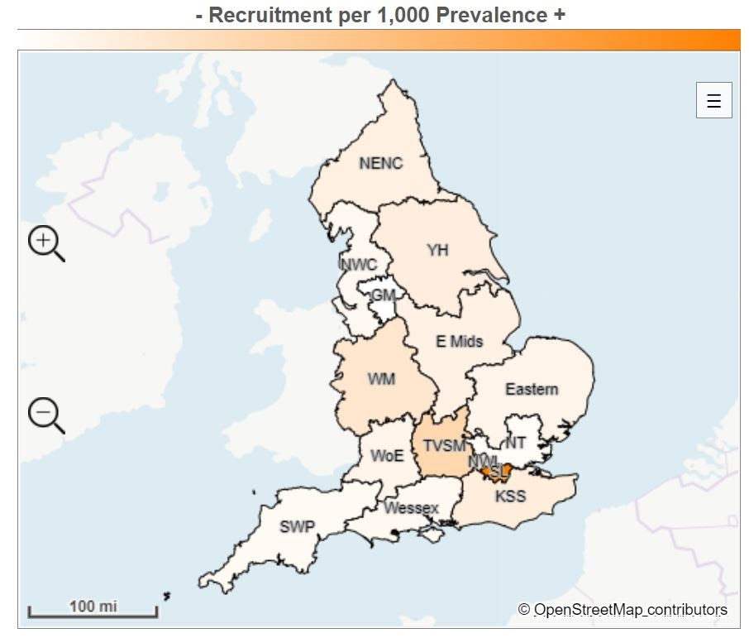

Local Clinical Research Network region | Recruitment | Prevalence | Recruitment per 100,000 prevalence
South London | 22,101 | 387,025 | 57.1
Thames Valley and South Midlands | 4,332 | 222,443 | 19.5
West Midlands | 7,484 | 568,463 | 13.2
North West London | 2,869 | 250,377 | 11.5
Kent, Surrey and Sussex | 4,286 | 426,269 | 10.1
Yorkshire and Humber | 6,145 | 630,356 | 9.7
North East and North Cumbria | 3,427 | 383,540 | 8.9
East Midlands | 3,442 | 420,127 | 8.2
Eastern | 3,108 | 418,186 | 7.4
West of England | 1,888 | 256,886 | 7.1
North West Coast | 2,929 | 521,317 | 5.6
Wessex | 1,559 | 289,753 | 5.4
South West Peninsula | 1,251 | 250,971 | 5.0
North Thames | 2,803 | 648,839 | 4.3
Greater Manchester | 1,133 | 430,692 | 2.6
England total | 68,757 | 6,114,244 | 11.2

Where are common mental health conditions most prevalent?
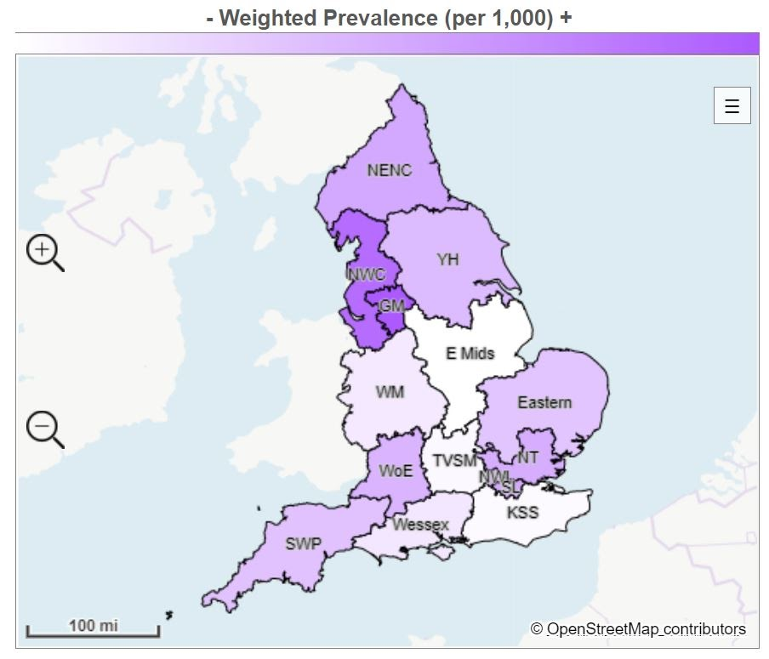

Local Clinical Research Network region | Prevalence | Adult population | Weighted prevalence (per 1,000)
Greater Manchester | 430,692 | 2,146,470 | 200.7
North West Coast | 521,317 | 2,707,490 | 192.5
North East and North Cumbria | 383,540 | 2,296,045 | 167.0
North West London | 250,377 | 1,505,994 | 166.3
South London | 387,025 | 2,328,617 | 166.2
North Thames | 648,839 | 3,952,295 | 164.2
West of England | 265,886 | 1,644,509 | 161.7
Yorkshire and Humber | 630,356 | 3,971,913 | 158.7
South West Peninsula | 250,971 | 1,611,110 | 155.8
Eastern | 418,186 | 2,704,008 | 154.7
Wessex | 289,753 | 2,065,847 | 140.3
West Midlands | 568,463 | 4,088,391 | 139.0
Thames Valley and South Midlands | 222,443 | 1,637,712 | 132.9
Kent, Surrey and Sussex | 426,269 | 3,218,657 | 132.4
East Midlands | 420,127 | 3,236,427 | 129.8
England total | 6,114,244 | 39,151,485 | 156.2

References:
- https://hrcsonline.net/health-categories/mental-health/
- https://hrcsonline.net/health-categories/neurological/
- https://www.cqc.org.uk/sites/default/files/20201124_cmh20_statisticalrelease.pdf
- https://www.gov.uk/government/publications/better-mental-health-jsna-toolkit/3-understanding-people
- NIHR Incubator for Medical Health
- NIHR Incubator for Social Care
Appendix Two

Useful external guidance

Various guidance and resources have been developed to guide and support research teams in working with communities, in line with the UK Public Involvement Standard on Inclusive Opportunities, including:

- Reaching Out: A Practical Guide to Being Inclusive in Health Research
This is a write up of the learning from some projects which NIHR delivered with communities to increase awareness of research and to work towards partnerships for designing and delivering research.

- Research Design Service - Community Engagement Toolkit
This resource is aimed at supporting researchers and communities to work together to develop research funding applications. It includes 10 guiding principles for effective community management.

- Health Inequalities Assessment Toolkit
This aims to help research teams and others to identify the inequalities associated with the health problem they want to tackle, to consider the social and economic causes of those inequalities, and to work out how they can plan and monitor their work to address these.

- Being Inclusive in Public Involvement in Health and Care Research
This is a short 12-point document, giving hints and tips for researchers and practitioners about how things to think about when you’re trying to work with individuals and communities on research

- Increasing Diversity in Research Toolkit (Centre for Ethnic Health Research)
This is a toolkit for researchers aimed at increasing the participation of Black, Asian and Ethnic Minority groups in health and social care research.

- REPAG Race Equality Framework
The Race Equality Public Action Group is a public led group formed of people from Black African, Asian and Caribbean heritage, working alongside researchers, to promote and take active steps to improve race equality in health and care research.

