NIHR Three Research Schools’ Mental Health Programme

Improving mental health and wellbeing in underserved populations through collaborative research

Commissioned call

Mental Health in Different Religious Groups

RESEARCH BRIEF

The NIHR Schools for Primary Care Research (SPCR), Public Health Research (SPHR) and Social Care Research (SSCR) (“three schools”) have joined together in a unique collaboration between leading academic centres in England to collaborate on three programmes of work funded through the National Institute for Health Research (NIHR): one on mental health led by SPCR, the second on dementia led by SSCR and the third on prevention led by SPHR.

Background:

At least one in four people experience mental health problems, many of whom never access care and treatment. There are also large numbers of people with learning disability (prevalence c.2%) and autism (prevalence c.1%). Mental health problems, learning disabilities and autism generate challenges for individuals with these conditions, their families and the wider society, with often quite high utilisation of health, social care and other services. Those challenges are seen across the life course.

The impacts of mental health problems on individuals and the wider societal and economic consequences are multiple and vast and include above-average rates of concurrent physical illnesses, shortened life expectancy, social exclusion, socioeconomic disadvantage, and the need for health and welfare support. Despite the high prevalence, many people do not receive the support they need and there are significant inequalities in access. These underserved groups include, but are not limited to, people with learning disabilities, older people, parts of the autistic and neurodiverse community, people from Black and other ethnic minority backgrounds. There are also other geographical, demographic and socioeconomic inequalities which this call addresses.

By working collaboratively across primary care, public health and social care, we aim to address problems in a multi-professional, multi-disciplinary way and at the individual, family, group and population levels using a variety of methodological approaches. Research will be underpinned by strong and diverse public, carer, service user and patient, and, as appropriate, practitioner involvement and engagement. Our research will prioritise those groups with high needs for treatment and support, and that have been underserved by research to date.

The requirement:

Funding awarded to the Three Schools in phase I (2021-24) has supported 53 projects (Three NIHR Research Schools' Mental Health Programme — NIHR School for Primary Care Research). Awards included a diverse range of partners, including practitioners, local authorities and those working in the third sector. Funding also achieved a wide geographical reach, actively working with populations and communities not traditionally engaged in research. We established a Fellowship scheme to develop new research capacity in key topic areas and localities in need of capacity development.

Research funding in phase 2 will build on early successes, supporting the implementation of evidence into practice and policy. In this funding call we are interested in applications with a specific focus on Mental Health in Different Religious Groups.

Opportunity

Funding of research through this programme requires collaboration between at least two different NIHR Schools. It is important that applicants ensure that they are listing collaborators who are member of one of the Three NIHR Schools:
NIHR School for Primary Care Research
NIHR School for Public Health Research
NIHR School for Social Care Research*

*SSCR has new membership from 1.5.24. However, NIHR have not yet announced the new members. If you have any queries, please contact Jen Hill, Programme Manager, NIHR SSCR.

The Principal Investigator must be based in one of the members of one of the three NIHR Schools (see links above). Collaborators from outside the three Schools are allowed but there must be collaboration from at least two of the three NIHR Schools.

The host organisation must be based in areas identified by the NIHR ‘heat map’ (appendix 1) as being underserved, however collaborators outside of these areas are welcome. Participant recruitment to the study must take place from the underserved region although this can be in conjunction with sites located in other regions, where the burden or need is high. The choice of recruitment regions and sub-localities must be justified in relation to the size of the impacts. We encourage applicants to use a mapping tool, such as the Research Targeting Tool (to access this please contact inforequest@nihr.ac.uk), to demonstrate how the planned target population fit with prevalence and impacts. Special consideration should be given to the inclusion of people from socioeconomically disadvantaged groups and other underserved communities that are more affected by mental health problems. Research methods may involve primary research or evidence synthesis, including systematic reviews, intervention development and testing, modelling studies, or the analysis of existing datasets.

Selection criteria:

Applications will be reviewed using the following criteria:

- Relevance and importance to the priorities and needs of primary care, public health and social care
- Clear alignment with the remit of the Three NIHR Research Schools’ Mental Health Programme
- Awareness and understanding of previous relevant research or developments in this area
- Feasibility of planned research
- Originality of planned research
- Appropriateness of the research design in relation to the stated objectives
- Appropriateness of the work plan and project management arrangements
- Strength of the research team
- Strength of the dissemination and impact plan
- Strength of the proposed plans for patient and public involvement throughout the duration of the research

Funding:

The maximum budget for each proposal is £50,000 for this call. This can fund:
- 100% of the directly incurred staff time on the project
- 100% of the directly allocated staff time on the project
- Overhead of 30% of the directly incurred staff cost
- Overhead of 30% of the directly allocated staff time cost
- 100% of the directly incurred non-pay items
- As this is NIHR funding, overheads cannot be applied to non HEI organisations, including; local authorities, NHS providers and other third party organisations. Non HEI organisations must be costed at 100%. Overheads should be removed from the ‘Institutions & Organisations’ worksheet of the costing template where appropriate.

Awards can be of any duration but STRICTLY must not extend beyond 31 March 2026.

Applications should be emailed to c.ashmore@keele.ac.uk by Monday 14 October 2024 no later than 3.30pm.

TIMETABLE

Tuesday 10 September 2024 | Competition launch
Monday 14 October 2024 at 3.30pm | Closing date for submission of applications
November 2024 | Panel meeting to discuss applications
November/December 2024 | Competition outcomes to be announced
January 2025 | Awards may start from this date

GUIDANCE NOTES

PART 1 – APPLICATION SUMMARY

Plain English Summary
Guidance on writing a plain English summary is available at https://www.nihr.ac.uk/documents/plain-english-summaries/27363

PART 2 – APPLICANT TEAM

Details of public co-applicant or collaborator
For further information please access the 'Public Co-Applicants in Research' guidance

NIHR Research Schools
A condition of the funding through this programme is there needs to be collaboration between at least two NIHR Research Schools, one who must be project lead.

It is important that applicants ensure that they are listing collaborators who are a member of one of the Three NIHR Schools:
NIHR School for Primary Care Research
NIHR School for Public Health Research
NIHR School for Social Care Research

PART 3 – DESCRIPTION OF PROPOSED RESEARCH

Details of proposed research
Do not exceed 6 pages of A4 for Part 3 including references which must be included below as part of the application form, and not submitted separately.

Equality, diversity and inclusion
Applicants should demonstrate how these factors have been considered and addressed in their proposal, including steps taken to ensure the research sample is representative of the population the study is targeted at. Please see the NIHR INCLUDE Guidance for more information about how to include under-served groups effectively.

PART 4 – PUBLIC INVOLVEMENT

How will patients/public/practitioners/people with lived experience/carers be involved in your research?
A list of PPI resources for applicants to NIHR research programmes to assist you can be found on the NIHR website, including: Briefing notes for researchers on how to involve patients/service users, carers and the public and Payments Guidance for researchers and professionals with information on budgeting for involvement

PART 5 –RELEVANCE OF PROPOSED RESEARCH

What are the likely impacts on policy and/or practice from this project?
https://www.nihr.ac.uk/researchers/apply-for-funding/how-to-apply-for-project-funding/plan-for-impact.htm

Appendix One

Analysis of Regional Mental Health Burden and Research Activity
There is a mismatch between regional research activities (measured by patient recruitment per 100,000 patients) in mental health and the prevalence of mental health conditions in England in the past 10 years (2010-19). The recruitment per 100,000 prevalence map shows where the highest proportion of people with mental health conditions are being recruited to research studies.

The areas of highest prevalence per 1,000 map shows where mental health conditions are most prevalent, with the shade becoming paler as prevalence drops.
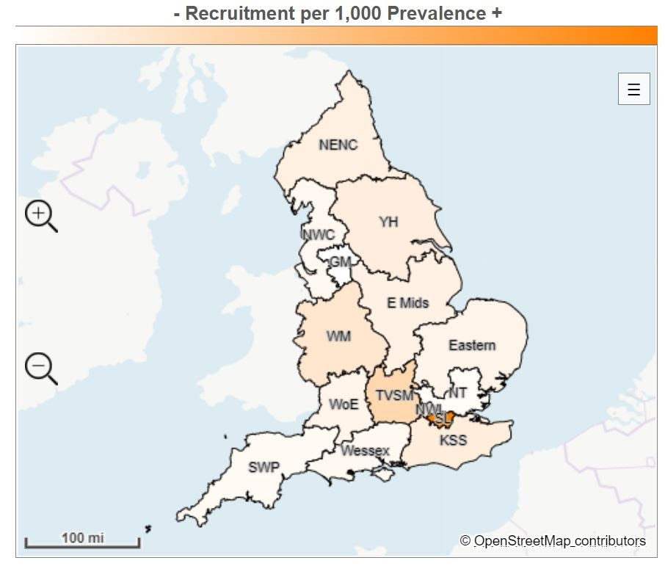

Local Clinical Research Network region | Recruitment | Prevalence | Recruitment per 100,000 prevalence
South London | 22,101 | 387,025 | 57.1
Thames Valley and South Midlands | 4,332 | 222,443 | 19.5
West Midlands | 7,484 | 568,463 | 13.2
North West London | 2,869 | 250,377 | 11.5
Kent, Surrey and Sussex | 4,286 | 426,269 | 10.1
Yorkshire and Humber | 6,145 | 630,356 | 9.7
North East and North Cumbria | 3,427 | 383,540 | 8.9
East Midlands | 3,442 | 420,127 | 8.2
Eastern | 3,108 | 418,186 | 7.4
West of England | 1,888 | 256,886 | 7.1
North West Coast | 2,929 | 521,317 | 5.6
Wessex | 1,559 | 289,753 | 5.4
South West Peninsula | 1,251 | 250,971 | 5.0
North Thames | 2,803 | 648,839 | 4.3
Greater Manchester | 1,133 | 430,692 | 2.6
England total | 68,757 | 6,114,244 | 11.2

Where are common mental health conditions most prevalent?
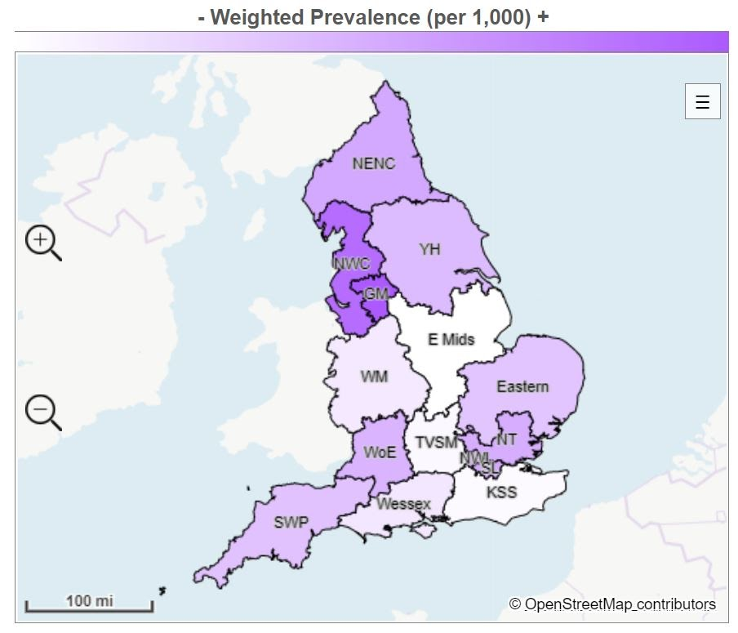

Local Clinical Research Network region | Prevalence | Adult population | Weighted prevalence (per 1,000)
Greater Manchester | 430,692 | 2,146,470 | 200.7
North West Coast | 521,317 | 2,707,490 | 192.5
North East and North Cumbria | 383,540 | 2,296,045 | 167.0
North West London | 250,377 | 1,505,994 | 166.3
South London | 387,025 | 2,328,617 | 166.2
North Thames | 648,839 | 3,952,295 | 164.2
West of England | 265,886 | 1,644,509 | 161.7
Yorkshire and Humber | 630,356 | 3,971,913 | 158.7
South West Peninsula | 250,971 | 1,611,110 | 155.8
Eastern | 418,186 | 2,704,008 | 154.7
Wessex | 289,753 | 2,065,847 | 140.3
West Midlands | 568,463 | 4,088,391 | 139.0
Thames Valley and South Midlands | 222,443 | 1,637,712 | 132.9
Kent, Surrey and Sussex | 426,269 | 3,218,657 | 132.4
East Midlands | 420,127 | 3,236,427 | 129.8
England total | 6,114,244 | 39,151,485 | 156.2

References:
- https://hrcsonline.net/health-categories/mental-health/
- https://hrcsonline.net/health-categories/neurological/
- https://www.cqc.org.uk/sites/default/files/20201124_cmh20_statisticalrelease.pdf
- https://www.gov.uk/government/publications/better-mental-health-jsna-toolkit/3-understanding-people
- NIHR Incubator for Medical Health
- NIHR Incubator for Social Care

