NIHR Three Research Schools’ Mental Health Programme

Improving mental health and wellbeing in underserved populations through collaborative research

Career Development Award

RESEARCH BRIEF

The NIHR Schools for Primary Care Research (SPCR), Public Health Research (SPHR) and Social Care Research (SSCR) (“three schools”) have joined together in a unique collaboration between leading academic centres in England to collaborate on three programmes of work funded through the National Institute for Health Research (NIHR): one on mental health led by SPCR, the second on dementia led by SSCR and the third on prevention led by SPHR.

Background:

At least one in four people experience mental health problems, many of whom never access care and treatment. There are also large numbers of people with learning disability (prevalence c.2%) and autism (prevalence c.1%). Mental health problems, learning disabilities and autism generate challenges for individuals with these conditions, their families and the wider society, with often quite high utilisation of health, social care and other services. Those challenges are seen across the life course.

The impacts of mental health problems on individuals and the wider societal and economic consequences are multiple and vast and include above-average rates of concurrent physical illnesses, shortened life expectancy, social exclusion, socioeconomic disadvantage, and the need for health and welfare support. Despite the high prevalence, many people do not receive the support they need and there are significant inequalities in access. These underserved groups include, but are not limited to, people with learning disabilities, older people, parts of the autistic and neurodiverse community, people from Black and other ethnic minority backgrounds. There are also other geographical, demographic and socioeconomic inequalities which this call addresses.

By working collaboratively across primary care, public health and social care, we aim to address problems in a multi-professional, multi-disciplinary way and at the individual, family, group and population levels using a variety of methodological approaches. Research will be underpinned by strong and diverse public, carer, service user and patient, and, as appropriate, practitioner involvement and engagement. Our research will prioritise those groups with high needs for treatment and support, and that have been underserved by research to date.

The requirement:

Phase 1 of funding awarded to the Three Schools has supported 53 projects (Three NIHR Research Schools' Mental Health Programme — NIHR School for Primary Care Research). Funding was awarded to a diverse range of partners, including practitioners, local authorities and those working in the third sector. Funding also achieved a wide geographical reach, actively working with populations and communities not traditionally engaged in research. We have established a Fellowship scheme to develop new research capacity in key topic areas and localities in need of capacity development.

Research funding in phase 2 would build on our early successes, supporting the implementation of evidence into practice and policy. As part of our second year monitoring, we identified a number of areas that are not significantly represented in phase 1. These include suicide prevention in high-risk groups (including those working in the agricultural sector and young men), mental health in pregnancy, prison mental health, mental health in different religious groups and mental health in military veterans, but applications are not limited to these areas.

Opportunity

For this Career Development Award call, we are inviting applications from those in the early stages of their mental health research careers to further develop their academic careers and build their research networks. We are particularly interested in applications from health and care professionals working in mental health but without a strong track record of mental health research (including but not limited to social work, nursing, midwifery, pharmacy, public health practitioners, housing providers, care home managers, paramedics) and methodologists (including social scientists, statisticians, economists and evidence synthesis experts) wishing to develop research careers in the area spanned by this programme. We will continue to draw on our expertise and established and recently developed networks to ensure strong lived experience (patient, carer, service user, practitioner, public and community) engagement, and work across traditional disciplinary and sector boundaries.

Funding of research through this Programme requires collaboration between at least two members of different NIHR Schools. The applicant must be linked to one of the university members of the three NIHR Schools:

NIHR School for Primary Care Research
NIHR School for Public Health Research
NIHR School for Social Care Research*

*SSCR has new membership from 1.5.24. However, NIHR have not yet announced the new members. If you have any queries, please contact Jen Hill, Programme Manager, NIHR SSCR.

The host organisation must be based in areas identified by the NIHR ‘heat map’ (appendix 1) as being underserved, however collaborators outside of these areas are welcome. Participant recruitment to the study must take place from the underserved region although this can be in conjunction with sites located in other regions, where the burden or need is high. The choice of recruitment regions and sub-localities must be justified in relation to the size of the impacts. We encourage applicants to use a mapping tool, such as the Research Targeting Tool (to access this please contact inforequest@nihr.ac.uk), to demonstrate how the planned target population fit with prevalence and impacts. Special consideration should be given to the inclusion of people from socioeconomically disadvantaged groups and other underserved communities that are more affected by mental health problems. Research methods may involve primary research or evidence synthesis, including systematic reviews, intervention development and testing, modelling studies, or the analysis of existing datasets.

The quality of the applications received will determine how many awards will be funded but all fellowships STRICTLY must end by 31 March 2026. Part time fellowships will be considered (0.6FTE minimum).

The maximum budget for each proposal is £30,000 for this call. The Programme will fund:
- 100% of the directly incurred staff time on the project
- 100% of the directly allocated staff time on the project
- Overhead of 30% of the directly incurred staff cost
- Overhead of 30% of the directly allocated staff time cost
- 100% of the directly incurred non-pay items

As this is NIHR funding overheads cannot be applied to non-HEI organisations, including; local authorities, NHS providers and other third-party organisations. 30% overheads can be applied to all HEI directly incurred and directly allocated staff costs. For non-HEI organisations up to 100% of direct costs can be costed.

Fellows will be based across the Three Schools’ Departments to ensure they receive the academic support needed to develop a strong research career within the remit of this programme. Cross-institutional supervision and exchange placements will be encouraged.

Each Fellow will become a member of one of the NIHR Schools and be able to access the wider resource available; which School will depend on professional background and research area. Fellows will also be allocated a second supervisor / mentor who is based in one of the other Schools, promoting cross-school working and awareness of the importance of cross-sector working. Each Fellow with have a personalised training budget to provide access to development activities including (and not limited to) leadership programmes and dissemination opportunities. It is anticipated that Fellows will also work on and lead other initiatives associated with this programme including workshops, dissemination and networking events.

Selection process

All applications received will be reviewed by a panel using these selection criteria. There will be no interviews for these awards.

PERSON
Commitment to research career in mental health research in the UK, particularly with reference to social care, primary care and/or public health and their interfaces
Knowledge of mental health priorities in England
Excellent written and verbal communication skills
Ability to manage own work with excellent organisational skills and attention to detail
Ability and motivation to pursue an independent research project
Evidence of ability to work as part of a team
Knowledge of some research methods
Previous research experience or formal training, allowing for career track and proposed career development
PROJECT
Relevance of proposed project to the Three Schools’ Mental Health Programme
Clarity of project aims
Patient and Public Involvement (PPI) - quality of plain English summary
PPI - involvement of practitioners/users/carers/patients/other experts by experience/the public in developing this proposal and active involvement throughout the proposed project
Consideration of equality, diversity and inclusion
Appropriate methodology proposed
Feasibility and likelihood of completion in available time
Fit between proposed project and proposed supervisory team interests and expertise
Attributes of the research environment to support the person and the proposed research project
Likelihood of being able to secure a further personal award or research funding at end of this fellowship

How to submit an application

Potential applicants are strongly encouraged to make contact with a member of the relevant School members to discuss your proposed project and agree supervisory arrangements.

It is important that applicants ensure that they are listing collaborators who are member of one of the Three NIHR Schools:
NIHR School for Primary Care Research
NIHR School for Public Health Research
NIHR School for Social Care Research*

*SSCR has new membership from 1.5.24. However, NIHR have not yet announced the new members. If you have any queries, please contact Jen Hill, Programme Manager, NIHR SSCR.

To apply please complete:
- Application form together with a short CV (two pages maximum). These must be submitted as Word documents.
- Costings form and submit as an Excel spreadsheet.
- Gantt chart which should provide timelines for the completion of work, including the timing of key milestones and deliverables. If there are several projects or work streams within the application, please specify these within the Gantt chart. You are welcome to use any visualisation software or template that works for your project.

Please email your final documents as detailed below to c.ashmore@keele.ac.uk by 3.30pm on Friday 15 November 2024.

Please state ‘Career Development Award’ in the subject line and your documents as:
- SURNAME_CDA_Application
- SURNAME_CDA_CV
- SURNAME_CDA_Gantt
- SURNAME_CDA_Costings

If you have any questions, please email Claire Ashmore, Programme Manager, Three NIHR Research Schools’ Mental Health Programme c.ashmore@keele.ac.uk

TIMETABLE

Monday 7 October 2024 | Competition launch
Friday 15 November 2024 at 3.30pm | Closing date for submission of applications
November/December 2024 | Panel meeting to discuss applications
November/December 2024 | Competition outcomes to be announced
January 2025 | Awards may start from this date

Analysis of Regional Mental Health Burden and Research Activity

There is a mismatch between regional research activities (measured by patient recruitment per 100,000 patients) in mental health and the prevalence of mental health conditions in England in the past 10 years (2010-19). The recruitment per 100,000 prevalence map shows where the highest proportion of people with mental health conditions are being recruited to research studies.

The areas of highest prevalence per 1,000 map shows where mental health conditions are most prevalent, with the shade becoming paler as prevalence drops.
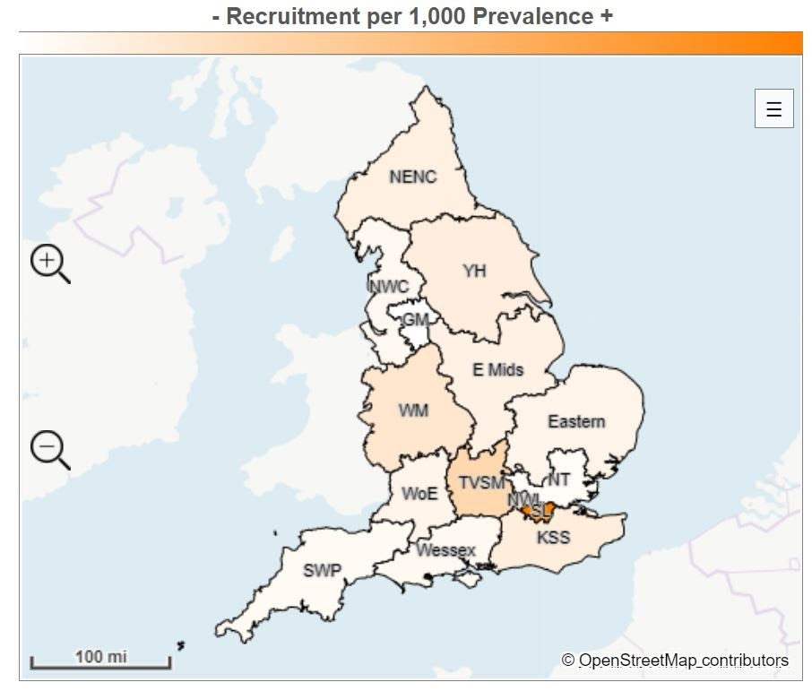

Local Clinical Research Network region | Recruitment | Prevalence | Recruitment per 100,000 prevalence
South London | 22,101 | 387,025 | 57.1
Thames Valley and South Midlands | 4,332 | 222,443 | 19.5
West Midlands | 7,484 | 568,463 | 13.2
North West London | 2,869 | 250,377 | 11.5
Kent, Surrey and Sussex | 4,286 | 426,269 | 10.1
Yorkshire and Humber | 6,145 | 630,356 | 9.7
North East and North Cumbria | 3,427 | 383,540 | 8.9
East Midlands | 3,442 | 420,127 | 8.2
Eastern | 3,108 | 418,186 | 7.4
West of England | 1,888 | 256,886 | 7.1
North West Coast | 2,929 | 521,317 | 5.6
Wessex | 1,559 | 289,753 | 5.4
South West Peninsula | 1,251 | 250,971 | 5.0
North Thames | 2,803 | 648,839 | 4.3
Greater Manchester | 1,133 | 430,692 | 2.6
England total | 68,757 | 6,114,244 | 11.2

Where are common mental health conditions most prevalent?
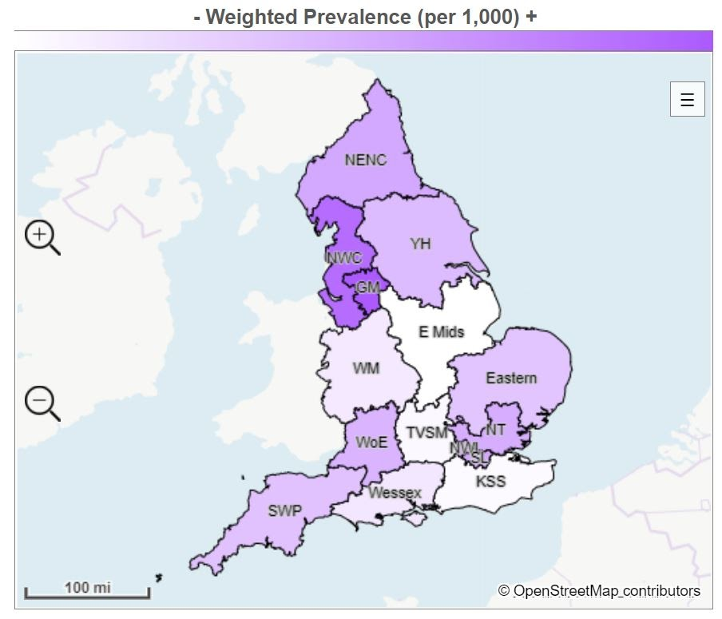

Local Clinical Research Network region | Prevalence | Adult population | Weighted prevalence (per 1,000)
Greater Manchester | 430,692 | 2,146,470 | 200.7
North West Coast | 521,317 | 2,707,490 | 192.5
North East and North Cumbria | 383,540 | 2,296,045 | 167.0
North West London | 250,377 | 1,505,994 | 166.3
South London | 387,025 | 2,328,617 | 166.2
North Thames | 648,839 | 3,952,295 | 164.2
West of England | 265,886 | 1,644,509 | 161.7
Yorkshire and Humber | 630,356 | 3,971,913 | 158.7
South West Peninsula | 250,971 | 1,611,110 | 155.8
Eastern | 418,186 | 2,704,008 | 154.7
Wessex | 289,753 | 2,065,847 | 140.3
West Midlands | 568,463 | 4,088,391 | 139.0
Thames Valley and South Midlands | 222,443 | 1,637,712 | 132.9
Kent, Surrey and Sussex | 426,269 | 3,218,657 | 132.4
East Midlands | 420,127 | 3,236,427 | 129.8
England total | 6,114,244 | 39,151,485 | 156.2

References:
- https://hrcsonline.net/health-categories/mental-health/
- https://hrcsonline.net/health-categories/neurological/
- https://www.cqc.org.uk/sites/default/files/20201124_cmh20_statisticalrelease.pdf
- https://www.gov.uk/government/publications/better-mental-health-jsna-toolkit/3-understanding-people
- NIHR Incubator for Medical Health
- NIHR Incubator for Social Care

NIHR Three Research Schools’ Mental Health Programme

Improving mental health and wellbeing in underserved populations through collaborative research

Career Development Award

GUIDANCE NOTES

PART 2 – WORK PLAN FOR DURATION OF FELLOWSHIP

NIHR Research Schools
A condition of the funding through this programme is there needs to be collaboration between at least two NIHR Research Schools, one who must be project lead. *SSCR has new membership from 1.5.24. However, NIHR have not yet announced the new members. If you have any queries, please contact Jen Hill, Programme Manager, NIHR SSCR.

PART 3 – CASE FOR SUPPORT

Plain English Summary
Guidance on writing a plain English summary is available at https://www.nihr.ac.uk/documents/plain-english-summaries/27363

PART 4 – PUBLIC INVOLVEMENT

How will patients/public/practitioners/people with lived experience/carers be involved in your research?
A list of PPI resources for applicants to NIHR research programmes to assist you can be found on the NIHR website, including: Briefing notes for researchers on how to involve patients/service users, carers and the public and Payments Guidance for researchers and professionals with information on budgeting for involvement

